Supplemental Tables and Figures
Table 1 Clinical information of Middle and late prematurity with LOS and pneumonia.
Variables | Preterm infants with LOS  N = 8 | Preterm infants with pneumonia, N = 8 | t/χ² | P value
Gestational age (weeks)ª | 33.72±1.64 | 34.48±1.78 | 0.346 | 0.395
Birth weight (g)ª | 2027.50±45.23 | 2096.30±54.89 | 1.05 | 0.789
Male gender ^{b} | 4（50%） | 5（62.5%） | 0.254 | 0.614
Exposure to antibiotics,  n (%) ^{b} | 6（75%） | 5(62.5%) | 0.291 | 0.590
cumulative human milk,  n (%) ^{b} | 6(75%) | 5(62.5%) | 0.291 | 0.590
Cesarean section, n (%) ^{b} | 5（62.5%） | 4（50%） | 0.254 | 0.614
Stool collection time between admission time（d）ª | 3.0±2.45 | 3.63±1.85 | 0.814 | 0.574
Age of admission(d)ª | 35.25±18.53 | 38.75±23.84 | 0.885 | 0.748
WBC（×10⁹/l）ª | 9.15±5.76 | 10.59±3.44 | 3.39 | 0.55
NUET(%)ª | 45.21±19.53 | 41.24±19.77 | 0.006 | 0.69
Plt(×10⁹/l)ª | 314.75±149.42 | 478.25±153.58 | 0.067 | 0.049
CRP(mg/l)ª | 5.93±6.88 | 6.03±13.76 | 0.44 | 0.99
PCT(ng/dl)ª | 4.41±12.02 | 0.12±0.08 | 5.35 | 0.33
Data are expressed as mean (standard error of the mean) for continuous variables or n (percentage) for categorical variables. Differences between the two groups were analyzed using the Mann-Whitney U test (marked as ª ) for quantitative variables. χ² test was used for categorical variables (marked as ^{b} ).
Supplementary Figure 1
The species accumulation curve of the sample.

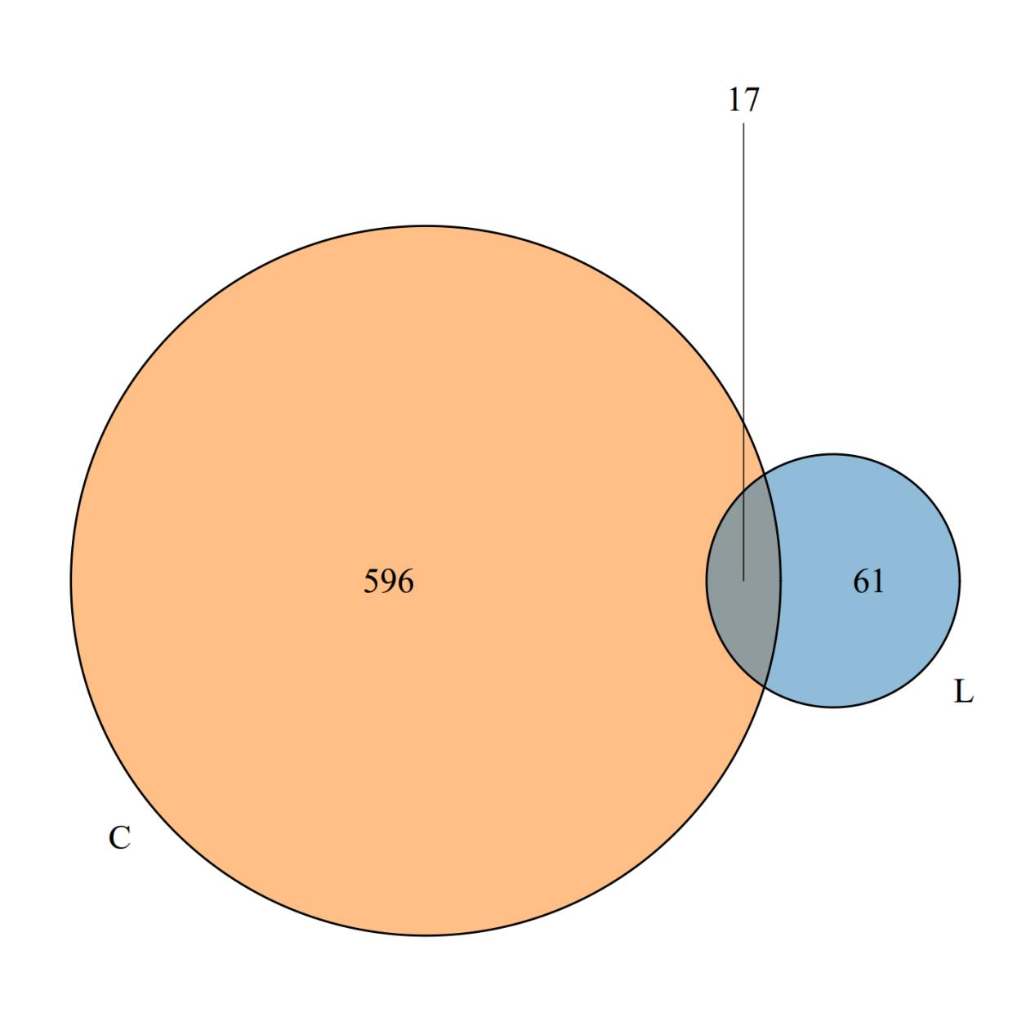
Supplementary Figure 2
Venn diagrams of the LOS and fecal groups.

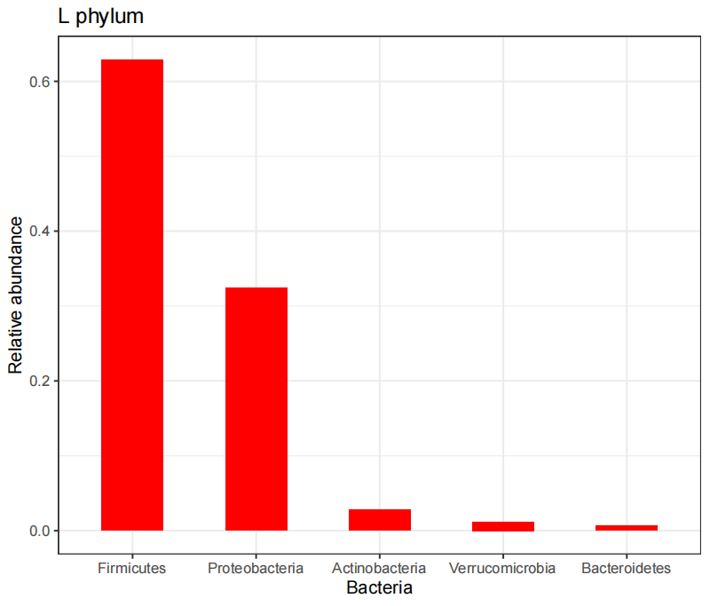
Supplementary Figure 3
The top five predominant phyla in the LOS group
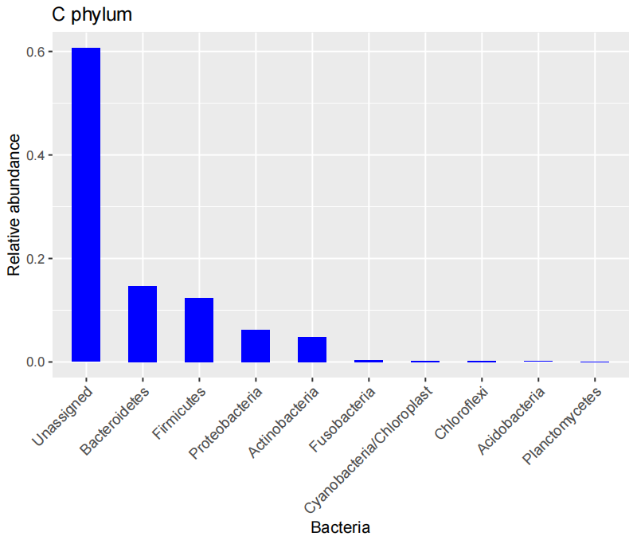
Supplementary Figure 4
The top ten predominant phyla of the control group
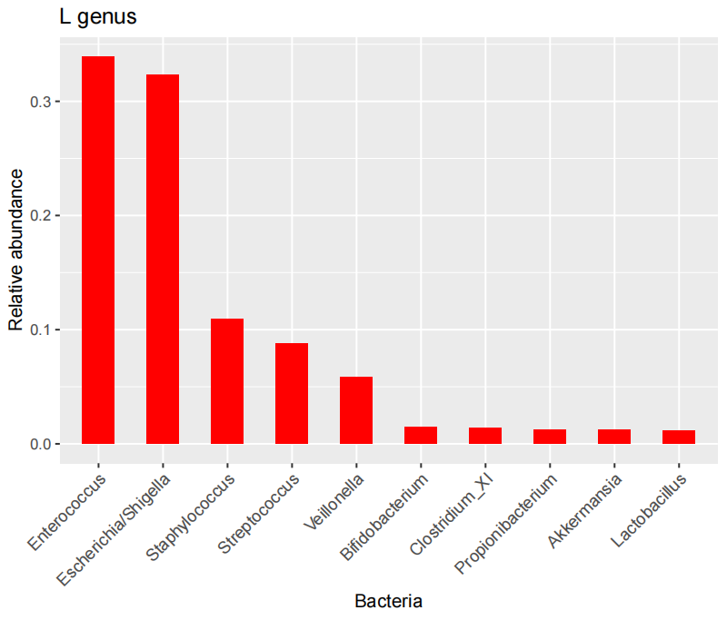
Supplementary Figure 5
The top ten predominant genera in the LOS group
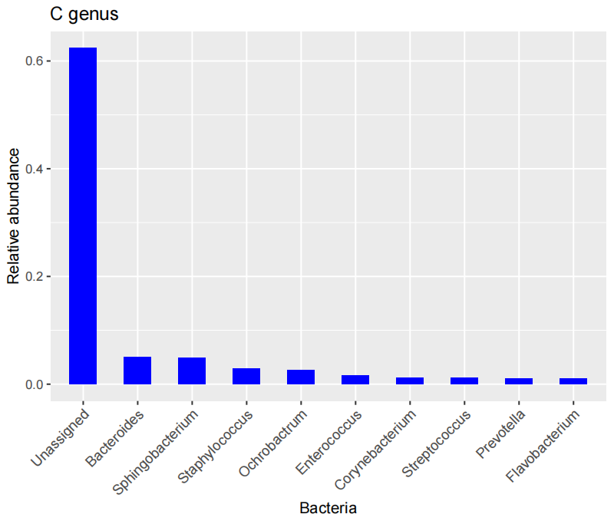
Supplementary Figure 6
The top ten predominant genera in the control group
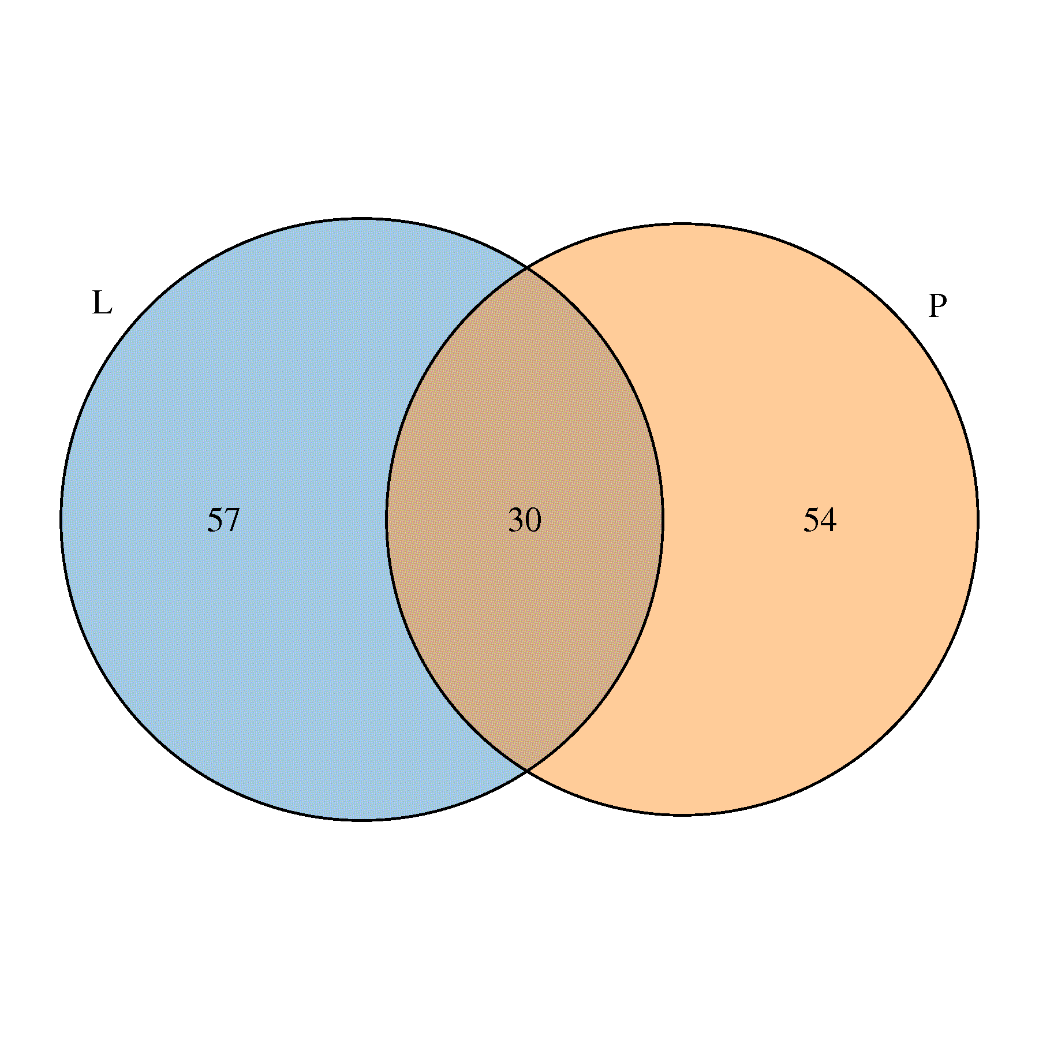
Supplementary Figure 7
Venn diagrams of the LOS group and pneumonia group

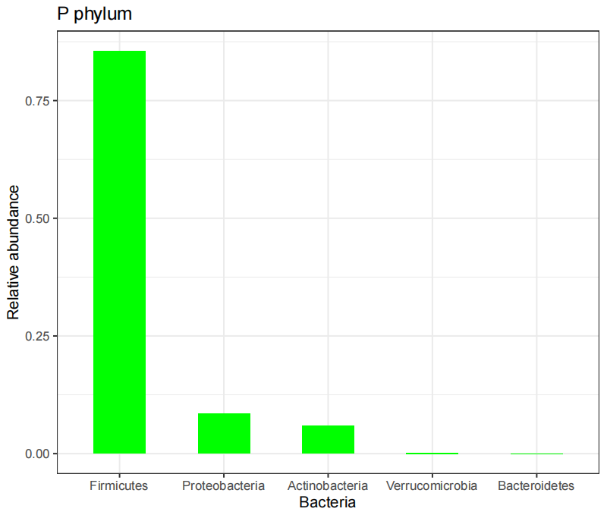
Supplementary Figure 8
The top phylum in pneumonia group

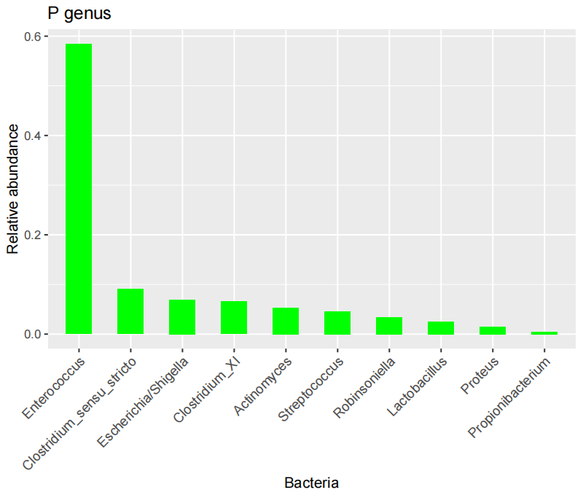
Supplementary Figure 9
The top ten predominant genus in pneumonia group

Group | n | Escherichia | Staphylococcus | Enterococcus | Bifidobacterium | Streptococcus | Lactobacillus
L（%） | 8 | 32.49±9.73 | 10.81±7.05 | 33.92±6.58 | 1.53±0.17 | 8.79±2.31 | 1.19±0.10
P（%） | 8 | 6.94±3.62 | 0.19±0.00 | 58.41±12.67 | 0.43±0.00 | 4.62±0.27 | 2.51±0.51
P |  | 0.04 | 0.09 | 0.165 | 0.325 | 0.672 | 0.752
Supplementary Table 2 Flora in the LOS group and pneumonia group
Abbreviations: L, late-onset sepsis;P, pneumonia.

Supplementary Figure 10
Venn diagrams of the pneumonia group and control group

